If you did not help Joe build more inverse function machines as directed on the last page of the comic, do that now. Notice that in the first three the function machine already has a function defined and you need to create the appropriate inverse function machine. You must make up your own function for the fourth function machine.
Go to geogebratube.org/student/m7567
For each of the six functions in the comic (f and g given in the story part of the comic and h, j, k and your own function on the “Help Joe build more inverse function machines page”), do the the following. (A screenshot for the function f given in the comic is shown below.
- enter the original function in the f(x) box
- check the checkboxes for f(x) and Trace
- slide the triangle on the x‐axis
- make an observation (or two!) and/or formulate a question (or two!)
Note that when you go to a new function, you can delete the trace for the previous function by unchecking and rechecking the trace box.
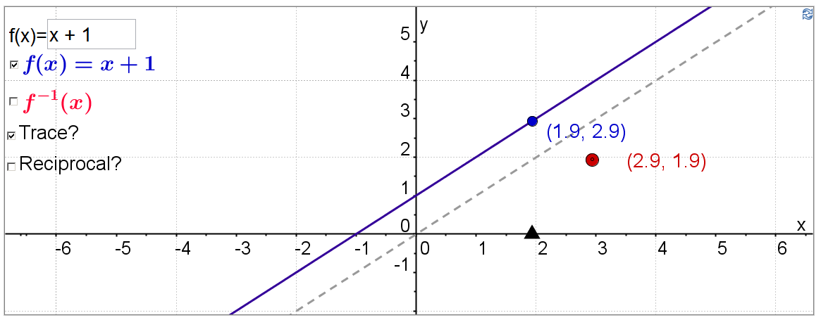
If you need to move the axes around to see a different part of the graph, Ctrl‐click anywhere in the white part of the graph and drag. If you need to rescale the axes, Ctrl‐click on the axis and drag. When you have finished, make at least one generalization or ask at least one question about functions and their inverses. Email it to me along with your score for this homework assignment.

